**Structure of the new VIA Software Homepage**

10.01.2021

**Structure:**

* Unternehmen / Company / About Us

Mainly the content of the document „VIA Software Unternehmensprofil.pdf” (see also “VIA Software Brochure - Draft Version in English Language.pdf”) with the categories as follows:

* + Who we are / Overview / Introduction (page 2 in the German version)
  + What we offer (Overview) / high level description for “Products” and the first two points of page 3 of „VIA Software Unternehmensprofil.pdf”
    - Products // some text high level + link to page or section “Products”
    - Custom Software Development // some text high level text + link to page or section “Custom Software Development”
    - IT Consulting and IT-Services
  + What makes us special / Our strength (as on page 4 in the German version)
    - Our Team
    - Well defined Standards
    - Innovative Development Tools
    - Comprehensive Module Library
    - Defining instead of Implementing
  + Our approach (as on page 5 in the German Version) // a short introduction and link to separate page “Our Approach”
  + Our Expertise (?) // we have it on our current website, I am not sure whether we should put on the new website as well (content see at the end of this document)
  + Our Values (as on page 6)
* Products // Please use dummy text for the time being unless some text is available like in the case of iplan
  + iplan Workforce Management // structure and main content of our iplan brochure “iplan 4.pdf” (a little abbreviated for the web page), also see web page [www.iplan4.de](http://www.iplan4.de) (a little bit outdated)
  + VIA Time Recording Solutions
    - Introduction // VIA Software offers a variety of solutions for time recording … (high level overview)
    - iplan activity report // project specific time recording
    - Time Recording with specific hardware devices
    - Smartphone Apps for Time Recording
    - Integration with iplan Workforce Management (optional)
  + VIA Project Management Solutions
    - Introduction, text about the benefit of using gantt charts, short explanation of VIA approach in this context // link to Gantt Chart Page (when this page exists)
    - VIA Project
    - iplan timeline
  + VIA Track & Trace Solutions
    - Introduction, short presentation of VIA offerings
    - Tracking and Tracing Solution with hardware GPS devices
    - Tracking and Tracing with Smartphone Apps
    - Integration of Tracking and Tracing in Client Applications
  + Software Developer Tools and Components // will be added in a second step
    - Introduction // Re-Usablity of components etc.
    - ER Modeling Tool
    - VIA Tables
    - VIA Gantt Chart
* Services
  + Custom Software Development
    - Complex Software Solutions
    - Web App Development
    - Smartphone App Development
    - Data Management and Digital Interfaces
  + IT Consulting and IT-Services
    - IT Consulting on all aspects of Digital Transformation
    - Requirements Engineering
    - System Design
    - Test Management and Quality Assurance
    - Software Maintenance …
    - Coaching
  + Operations Research
    - Development of Mathematical Models
    - Combinatorial Optimization
    - Forecasting
    - Prototyping
    - Implementation
* Case Studies and Selected Projects
  + We have 5 detailed case studies so far
  + Furthermore the content of the brochure “Ausgewählte Projekte von VIA Software.pdf” / “Selected Projects of VIA Software_Brochure.pdf” might be shown (abbreviated) organized in the way as in the brochure (which allows to have links to the sub categories)
* Blog / Posts // We are intending to publish articles about news concerning the product development of VIA Software or other blog articles regularly
* Downloads // there will be documents (e.g. Flyers, Brochures in pdf format) and step by step I would like to include software downloads (e.g. trial versions)   
  Important: Some of the downloads can be done right away without given a name etc., others require that the client fills a short form and at least leaves his name and email address
* Customer Support // customer specific login required // this page and the content will be implemented in a later step
* Contact Page // including the option to upload a document, e.g. a project specification
* Impress
* Career // Job Offers
* Privacy Policy

**Examples of what I like on other pages:**

I like the condensed view showing services as on   
<http://www.sbp-romania.com/CompanyServices/>

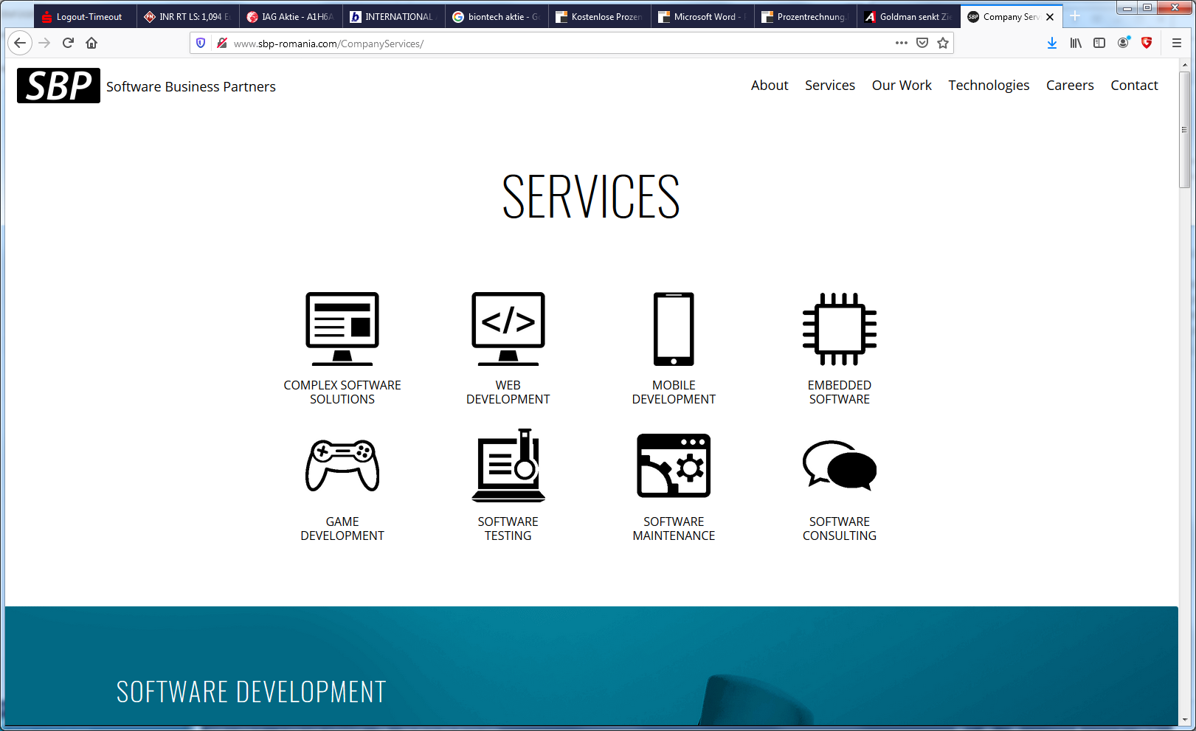

I imagine that on the new VIA homepage we will communicate very clearly in a similar way what exactly we offer (not necessary with icons).

What would that be? First, a selection from the above (also see structure above):

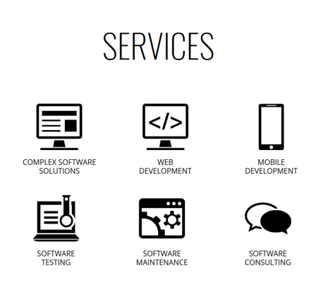

On the new website we might structure our offerings as follows:

For “Custom Software Development”

(as stated above on page 2)

**Custom Software Development**

* Complex Software Solutions
* Web App Development
* Smartphone App Development
* Data Management and Digital Interfaces

For the high level presentation I could imagine something like in the leverage theme (see three examples / screenshots below).

Instead of explaining all the topics in detail we might have links to the case studies and projects page or each topic. So, below each of the 4 sub topics there might be a button or link with a text like “Show Project Examples” or something like this.

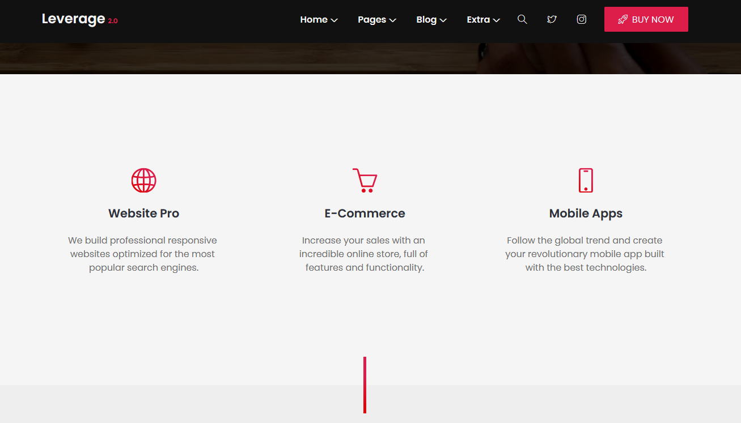

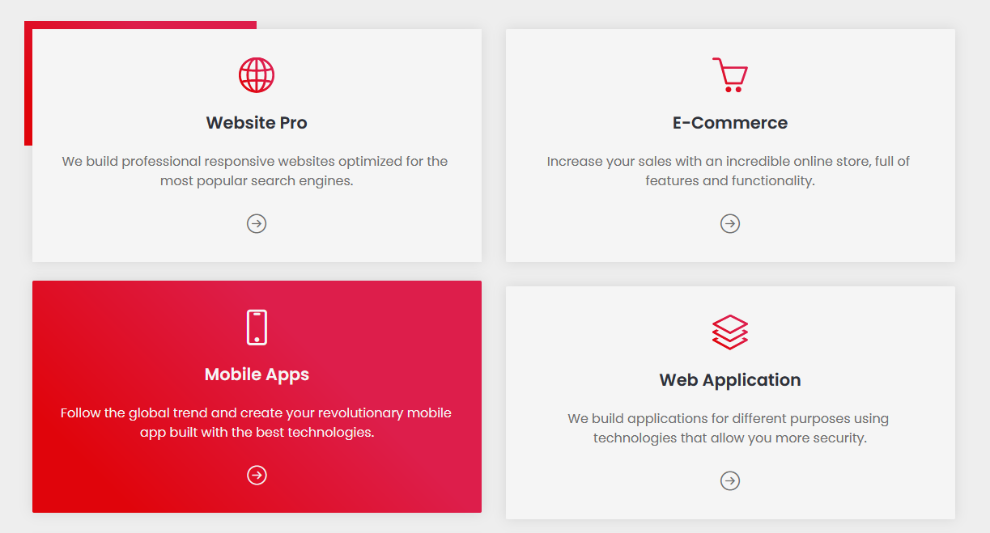

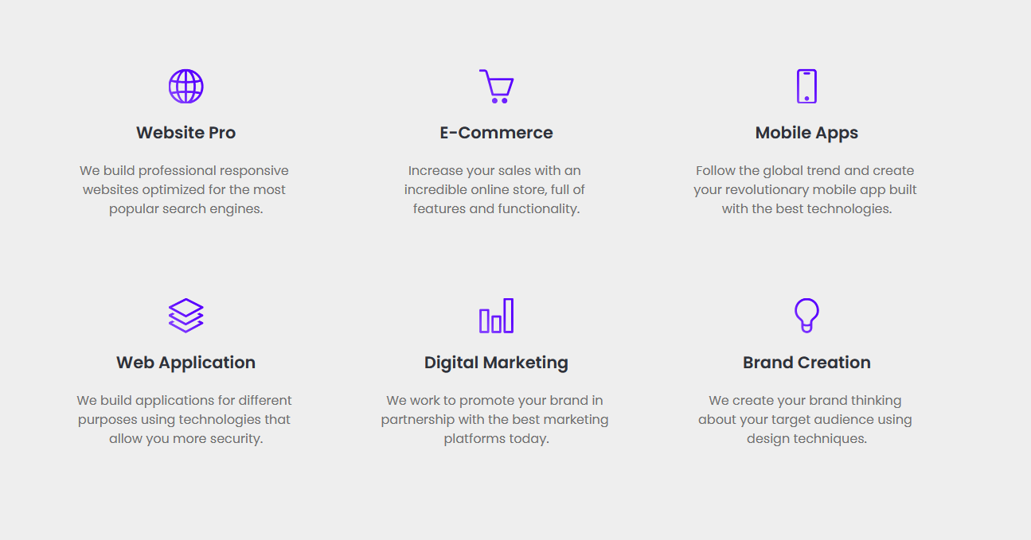

For “IT Consulting and IT-Services”

**IT-Services**

We would have some introduction text informing that we offer IT Consulting on all aspects of Digital Transformation and are covering the whole software development process.

* Requirements Engineering
* System Design
* Software Testing (maybe better than “Test Management and Quality Assurance”)
* Software Maintenance
* Coaching // maybe added later

So, then we would also have 4 sub categories for the time being and we could arrange them in a similar way than in the case of “Customr Software Development”

**Operations Research**

Here we might show a structure as follows:

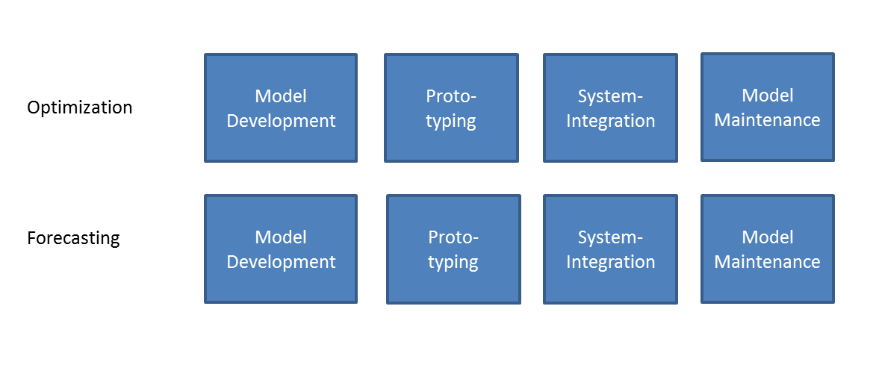

So, as well for “Optimization” and “Forecasting” we have 4 phases in each case. From the high level visualization of these items we might as well (as above) have links to the page showing Case Sudies and example projects.

**Our Approach**

For “Our Process” or “Our Approach” I like a high level visualization as below (taken from the Adri theme).

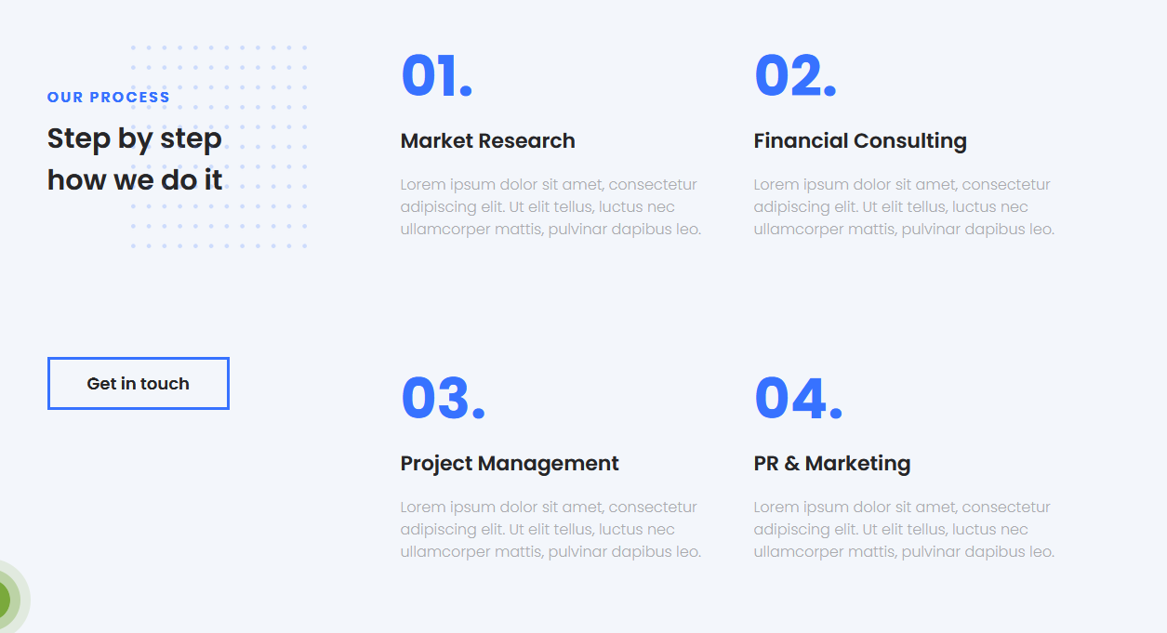

**Cases Studies and Reference Projects (or Example Projects, however we call it)**

I like a presentation where the case studies are represented by images as in the case of the lavage theme (see three examples below)

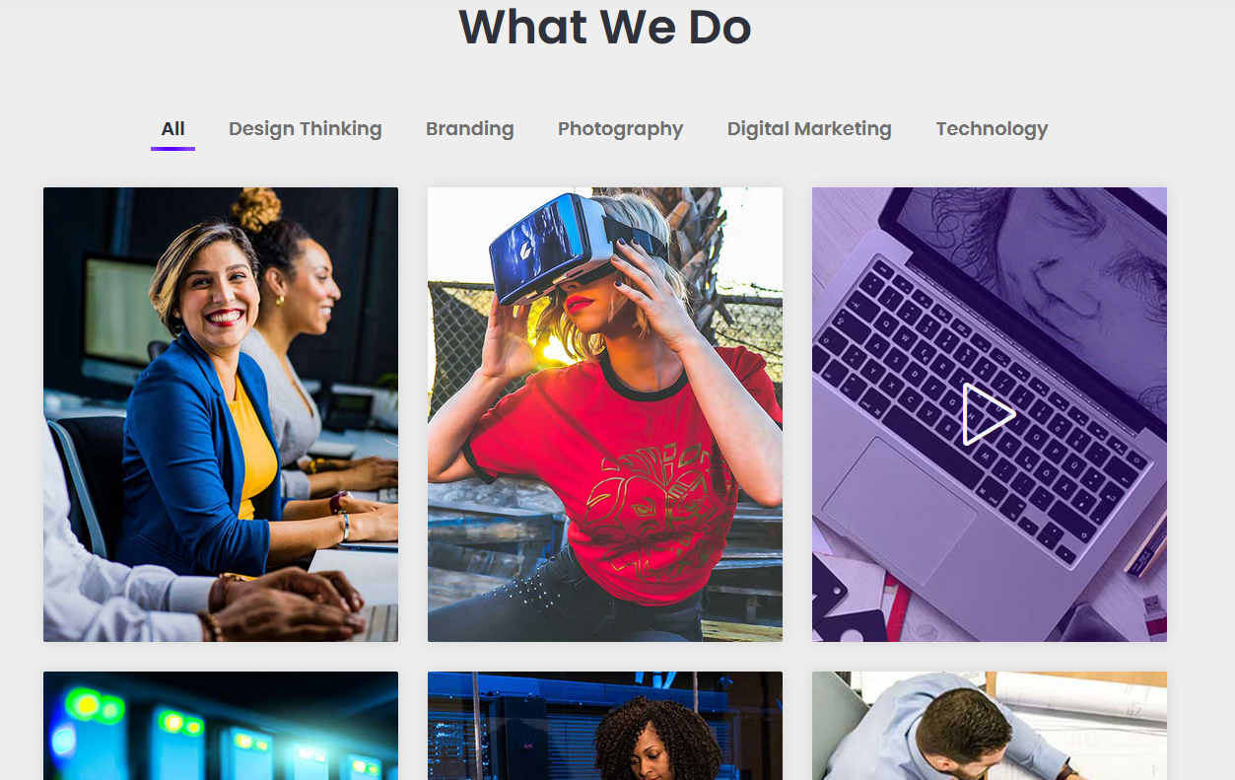

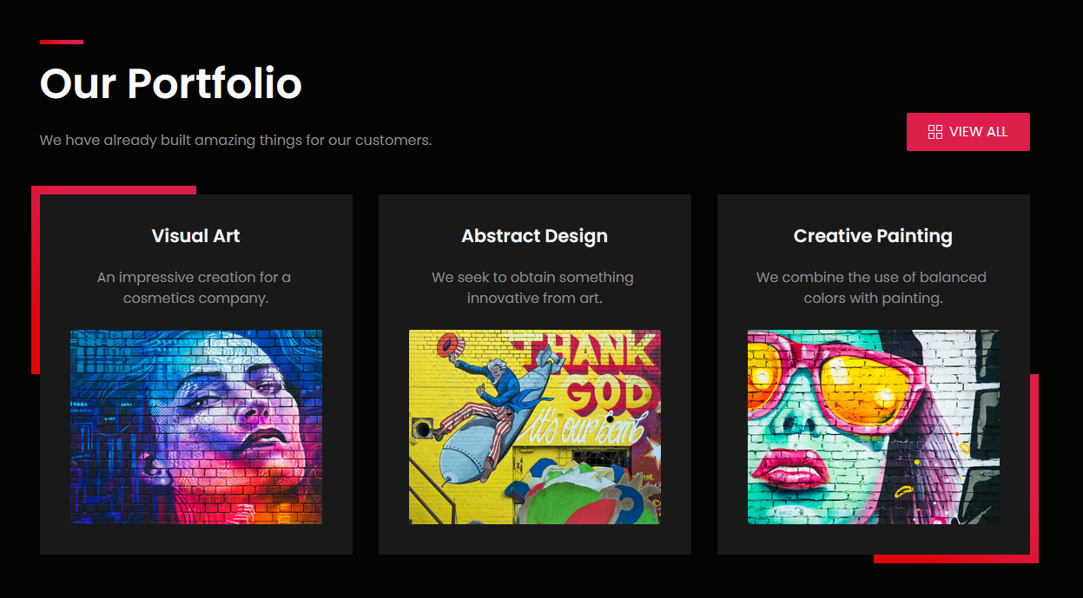

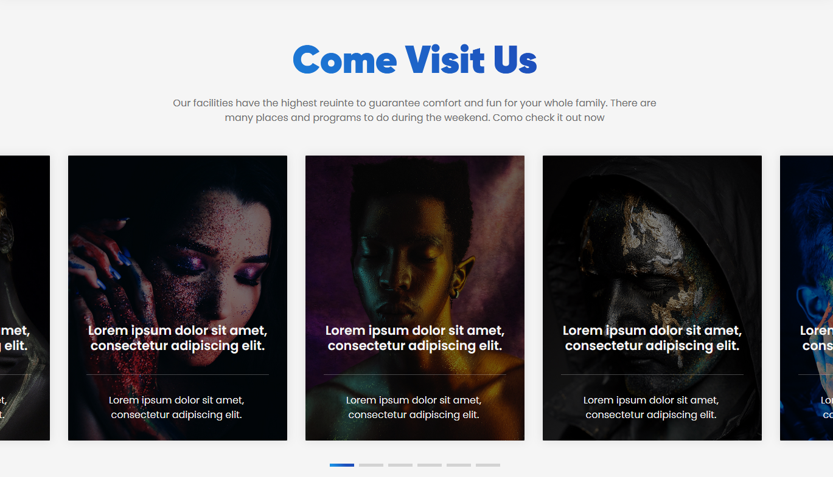

**Get in Touch**

Another element of the new VIA website should be a contact form, possibly with the option of a project request. The company “Altexsoft” has the following here:

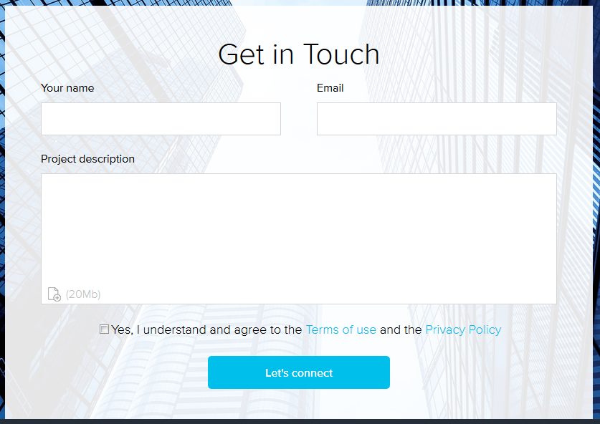

**Content of possible page / section „VIA Software Expertise“:**

* Operations Research
  + Mathematical Modeling
  + Optimization
  + Forecasting
* Data Science and Artificial Intelligence
* Software Engineering
  + Requirements Engineering
  + User Interface Design
  + Prototyping
  + Efficient Algorithms and Data Structures
  + Agile Development
  + Test Management (Testing?) and Quality Assurance
  + Technical Documentation and User Documentation
  + Software Maintenance and Enhancements
* Project Management

Remarks: For the prototype of the new page texts might be taken from today website [www.via-software.de](http://www.via-software.de) where the topics match:

VIA Software Expertise today (current website)

* Mathematical Modeling
* Operations Research
* Business Analytics
* Big Data Architectures
* Artificial Intelligence
* Software Engineering

**What I liked further:**

Film in the background:

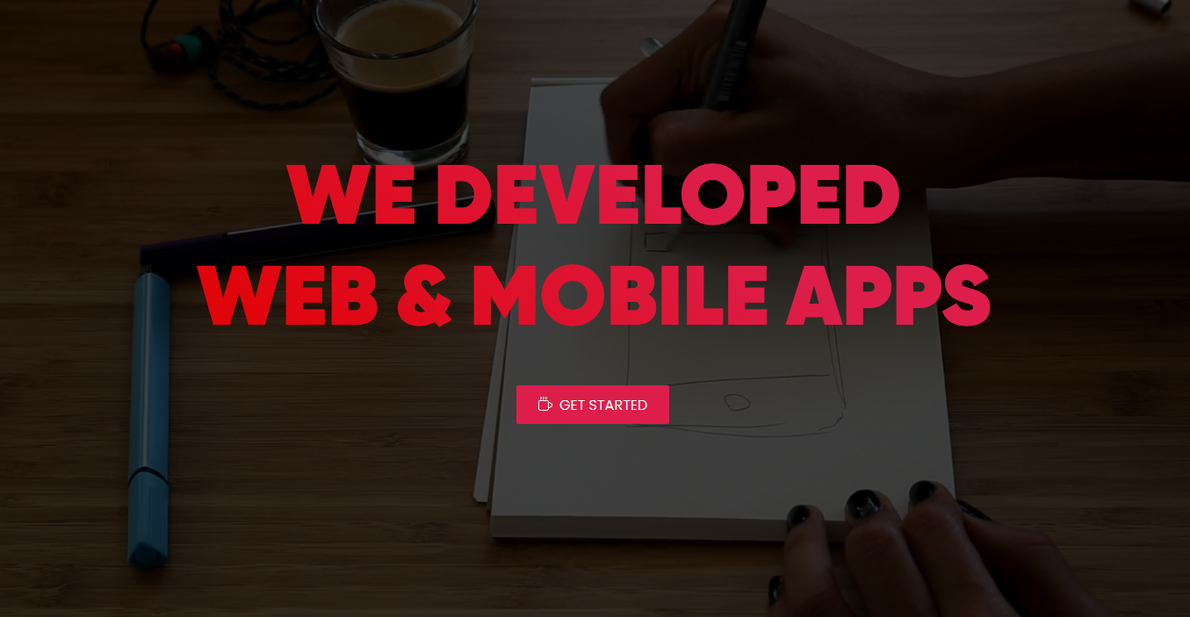

Background Photos and Title Animation “Experience” and “Innovation”. We might have three or more images and texts like this, e.g. for our main offerings (?) or for our values (?). I need to think about this…

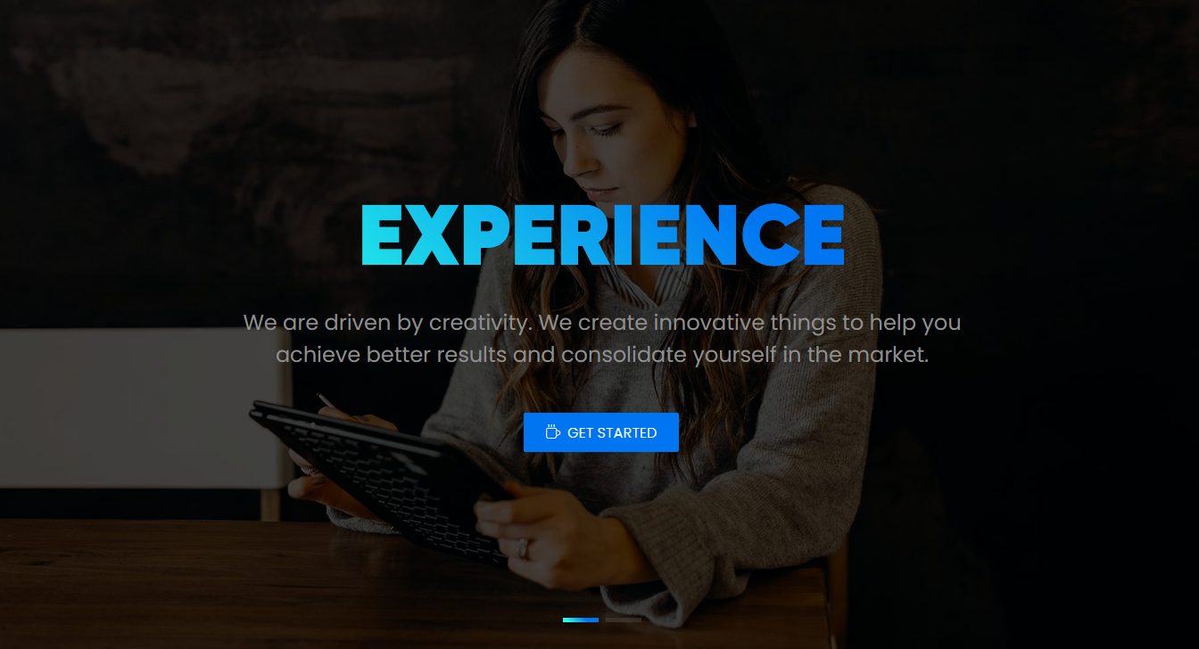

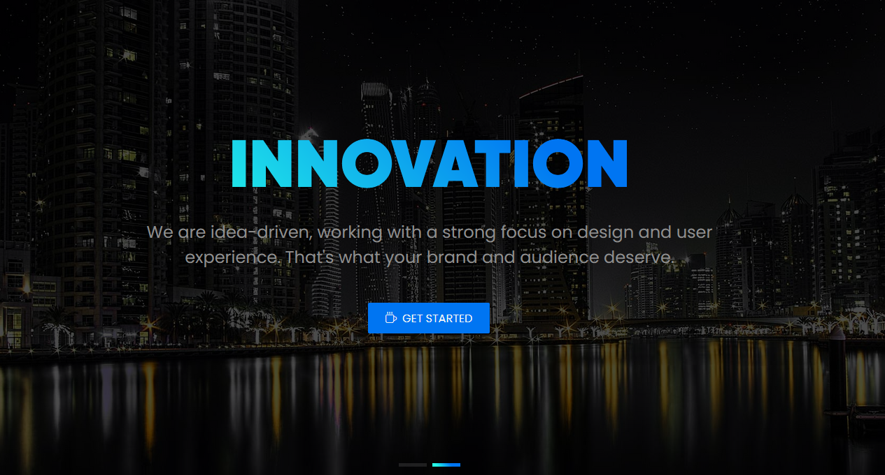

I liked the menu of the Adri theme since it seems that this menu can contain also icons and a short text explaining the options.

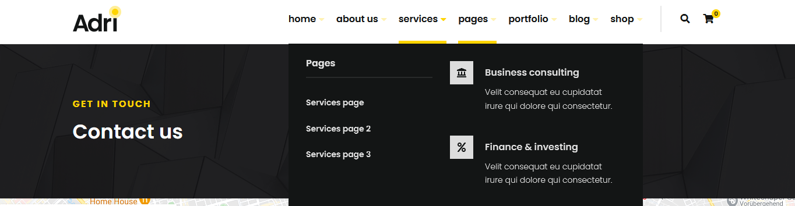

In any case I would like to have a page footer as in the case of the leverage theme and the adri theme:

